P. Lakshmivani
192365018
CSA1013

CO4 ASSESSMENT TOOL 1 – TEST CASE DESIGN ASSIGNMENT
Smart Cold Storage Monitoring and Food Preservation System
Field | Details | Field | Details
Course Code | CSA1013 | Course Title | Software Engineering
CO Assessed | CO4 | Assessment | Assessment Tool 1 – Test Case Design Assignment
Weightage | 20% | Total Marks | 25
Student Name | P. Lakshmivani | Reg. No. | 192365018
Date | 19-08-2026 | Duration | 60 minutes
ASSESSMENT QUESTION
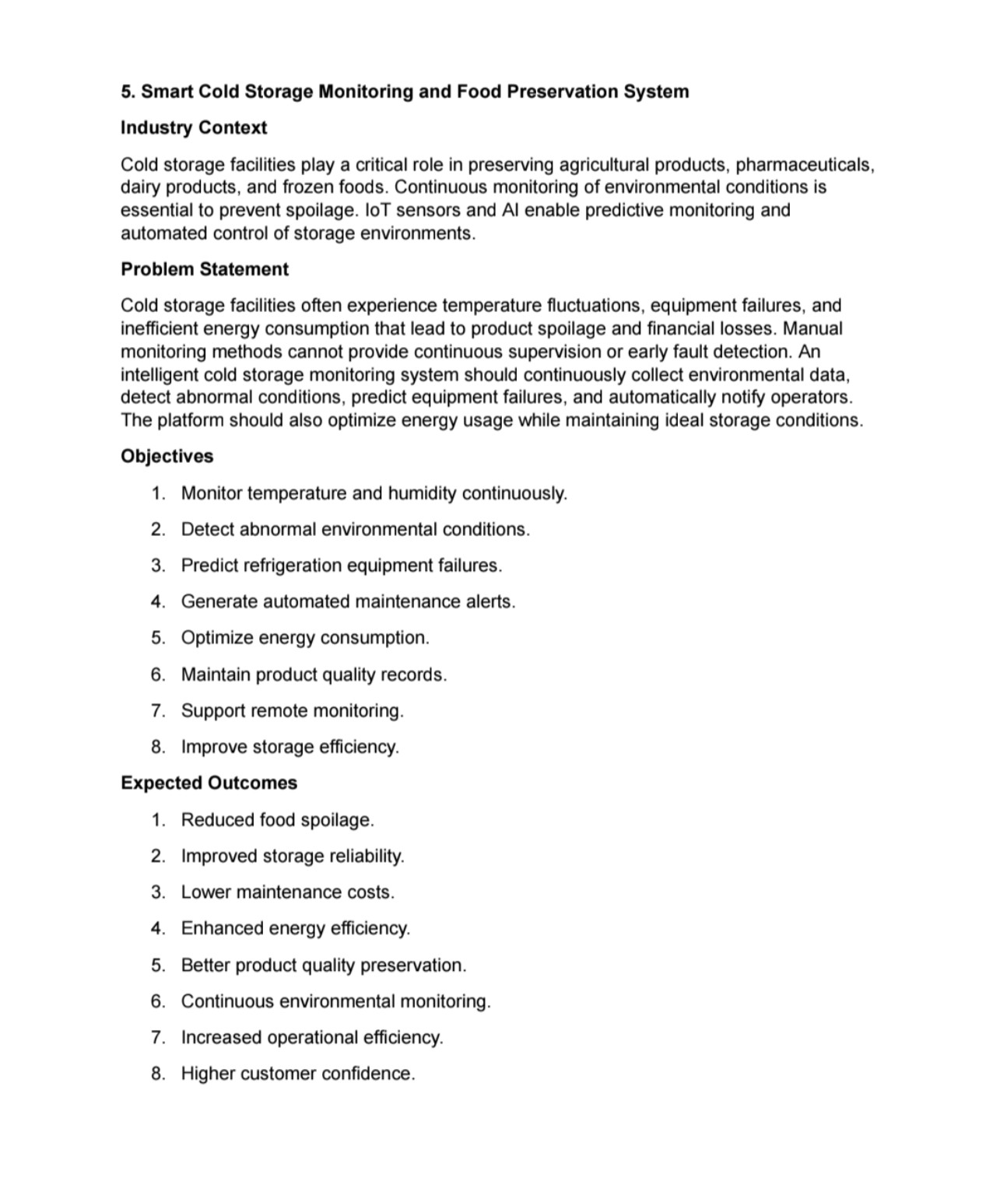
Test case design for the assigned Smart Cold Storage Monitoring and Food Preservation System.

1. Requirement Identification
1.1 Functional Requirements
ID | Requirement | Description
FR01 | Continuous Monitoring | Collect temperature and humidity readings continuously.
FR02 | Data Recording | Store readings with date and time.
FR03 | Abnormal Detection | Detect values outside acceptable storage conditions.
FR04 | Equipment Monitoring | Monitor refrigeration-related operating indicators.
FR05 | Failure Prediction | Analyze historical information to predict possible equipment failure.
FR06 | Maintenance Alerts | Generate automated alerts for maintenance conditions.
FR07 | Energy Optimization | Monitor and analyze energy consumption.
FR08 | Quality Records | Maintain product quality and environmental records.
FR09 | Remote Monitoring | Allow authorized operators to view storage conditions remotely.
FR10 | Storage Efficiency | Provide information that supports improved storage operation.
1.2 Non-Functional Requirements
• Reliability – monitoring should continue for long operating periods.
• Performance – recent readings and alerts should be displayed with minimal delay.
• Security – only authorized users should access monitoring and control functions.
• Usability – alerts and environmental status should be easy to understand.
• Scalability – additional rooms and sensors should be supportable.
• Maintainability – modules should be easy to test, modify and extend.
• Data integrity – environmental records should not be silently lost or corrupted.
1.3 Test Objectives
Testing will verify correctness, functionality, reliability and usability of the monitoring system. The test set covers normal, boundary, invalid and exceptional conditions, as required by the assessment format.

2. Test Scenario Identification
ID | Scenario | Description | Requirement
TS01 | Sensor monitoring | Verify continuous temperature and humidity collection. | FR01
TS02 | Data recording | Verify readings are stored with correct timestamp. | FR02
TS03 | Safe condition | Verify normal readings are accepted. | FR03
TS04 | High temperature | Verify high temperature is detected and alerted. | FR03
TS05 | Low temperature | Verify low temperature is detected and alerted. | FR03
TS06 | High humidity | Verify excessive humidity is detected. | FR03
TS07 | Equipment status | Verify refrigeration indicators are monitored. | FR04
TS08 | Failure prediction | Verify prediction module processes historical data. | FR05
TS09 | Maintenance alert | Verify maintenance alert is generated. | FR06
TS10 | Energy monitoring | Verify energy readings are recorded and displayed. | FR07
TS11 | Quality record | Verify product-quality records are maintained. | FR08
TS12 | Remote dashboard | Verify authorized user can monitor remotely. | FR09
TS13 | Unauthorized access | Verify unauthorized user is denied. | NFR-Security
TS14 | Sensor failure | Verify missing/invalid sensor input is handled. | NFR-Reliability
TS15 | Network failure | Verify temporary communication failure is handled. | NFR-Reliability
TS16 | Database failure | Verify application handles storage failure safely. | NFR-Reliability
2.1 Test Categories
• Normal conditions
• Boundary conditions
• Invalid inputs
• Exceptional conditions
• Security conditions
• Reliability and recovery conditions
• Remote usability conditions

3. Detailed Test Cases – Normal Conditions
ID | Test Scenario | Test Steps / Action | Test Data | Expected Result | Actual Result | Status
TC001 | Normal temperature | Login and open monitoring screen; provide safe temperature. | Temperature within configured safe range. | Reading displayed as normal and recorded.
TC002 | Normal humidity | Provide humidity within safe range. | Humidity within configured range. | Humidity shown as normal and stored.
TC003 | Continuous reading | Keep sensor active for multiple intervals. | Valid readings at regular intervals. | New readings appear at expected intervals.
TC004 | Timestamp recording | Submit a valid sensor reading. | Current date/time. | Record contains correct timestamp.
TC005 | Dashboard refresh | Open dashboard and wait for next reading. | New sensor value. | Dashboard updates with latest reading.
TC006 | Quality record | Create a product quality record. | Valid product details. | Record is saved successfully.
TC007 | Remote monitoring | Login as authorized operator from remote interface. | Valid credentials. | Current storage status is visible.
TC008 | Energy record | Submit valid energy reading. | Positive energy value. | Energy usage is stored and displayed.

4. Detailed Test Cases – Boundary Conditions
ID | Scenario | Test Steps / Action | Test Data | Expected Result | Actual Result | Status
TC009 | Temperature lower boundary | Enter the minimum permitted temperature. | Exactly minimum limit. | System applies the defined boundary rule correctly.
TC010 | Temperature upper boundary | Enter the maximum permitted temperature. | Exactly maximum limit. | System applies the defined boundary rule correctly.
TC011 | Temperature just above limit | Enter a value slightly above maximum. | Maximum + small increment. | Abnormal condition is detected and alert generated.
TC012 | Temperature just below limit | Enter a value slightly below minimum. | Minimum - small decrement. | Abnormal condition is detected and alert generated.
TC013 | Humidity lower boundary | Enter minimum allowed humidity. | Exactly minimum limit. | Value handled according to configured range.
TC014 | Humidity upper boundary | Enter maximum allowed humidity. | Exactly maximum limit. | Value handled according to configured range.
TC015 | Alert threshold boundary | Set threshold equal to current reading. | Reading = configured threshold. | System follows the documented threshold rule.
TC016 | Zero energy value | Submit zero energy consumption when valid. | 0. | Value is accepted only if zero is permitted.
Boundary Value Analysis is applied by testing values at, immediately above and immediately below important environmental limits. The exact numerical limits should be replaced with the limits configured for the implemented system.

5. Detailed Test Cases – Invalid Conditions
ID | Scenario | Test Steps / Action | Test Data | Expected Result | Actual Result | Status
TC017 | Invalid temperature text | Send non-numeric temperature input. | 'abc'. | Input is rejected and validation error is logged.
TC018 | Missing temperature | Send reading without temperature field. | Temperature = null. | System rejects incomplete reading safely.
TC019 | Invalid humidity | Send non-numeric humidity. | 'xyz'. | Invalid input is rejected.
TC020 | Negative humidity | Submit physically invalid humidity value. | -10%. | System rejects or flags invalid value.
TC021 | Invalid energy value | Submit text instead of numeric energy. | 'power'. | Input is rejected.
TC022 | Invalid login | Attempt dashboard login with wrong password. | Incorrect password. | Access denied without exposing sensitive information.
TC023 | Unauthorized API request | Call protected endpoint without authorization. | No valid token/session. | Request is rejected.
TC024 | Invalid product record | Submit incomplete product-quality data. | Missing required field. | Validation message is shown and record is not stored.
5.1 Equivalence Partitioning
Equivalence Partitioning divides input into valid and invalid groups. For example, environmental readings can be divided into safe values, values above the permitted range and values below the permitted range. Representative values from each group reduce unnecessary duplicate testing while maintaining functional coverage.

6. Detailed Test Cases – Exceptional Conditions
ID | Scenario | Test Steps / Action | Test Data | Expected Result | Actual Result | Status
TC025 | Temperature sensor failure | Disconnect or disable sensor. | No sensor response. | Failure is detected and warning is generated.
TC026 | Humidity sensor failure | Simulate missing humidity reading. | Timeout/null. | System logs the failure and avoids treating it as a normal value.
TC027 | Network interruption | Disconnect network during monitoring. | Temporary network loss. | System records/logs communication failure and recovers when connection returns.
TC028 | Database unavailable | Stop database service while application runs. | Database unavailable. | Application handles error without crashing unexpectedly.
TC029 | Power restart | Restart monitoring controller/application. | System restart. | System returns to monitoring and preserves persistent records.
TC030 | Repeated abnormal values | Send abnormal readings continuously. | Multiple unsafe readings. | Alert handling avoids uncontrolled duplicate notifications while maintaining records.
TC031 | Prediction service unavailable | Stop analytics/prediction service. | Service unavailable. | Core monitoring continues and failure is clearly reported.
TC032 | Large historical dataset | Process a large set of stored readings. | Large dataset. | System processes data within acceptable response time.
6.1 State Transition Testing
The system can be viewed through states such as NORMAL → WARNING → CRITICAL → RECOVERED. Testing should verify that valid sensor events cause the correct state transition, alerts are generated at the appropriate stage, and the system returns to NORMAL after conditions become safe.

7. Test Design Techniques
7.1 Equivalence Partitioning
Inputs are divided into valid and invalid partitions. For temperature, representative safe, high and low values can be selected. For user authentication, valid credentials and invalid credentials form separate partitions.
7.2 Boundary Value Analysis
Boundary testing focuses on values at the edges of acceptable ranges and just outside them. This is particularly important for temperature and humidity because the monitoring system must respond correctly when conditions approach or cross configured limits.
7.3 Decision Table Testing
Condition | Safe Temp | Safe Humidity | Equipment Normal | Expected System State
D1 | Yes | Yes | Yes | NORMAL
D2 | No | Yes | Yes | WARNING/ALERT
D3 | Yes | No | Yes | WARNING/ALERT
D4 | No | No | Yes | CRITICAL/ALERT
D5 | Yes | Yes | No | MAINTENANCE ALERT
D6 | No | No | No | CRITICAL + MAINTENANCE ALERT
7.4 State Transition Testing
Current State | Event | Next State | Expected Action
NORMAL | Temperature exceeds limit | WARNING | Generate warning.
WARNING | Condition becomes critical | CRITICAL | Generate critical alert.
CRITICAL | Condition returns safe | RECOVERED | Record recovery.
RECOVERED | Stable safe reading | NORMAL | Clear active warning.
7.5 Security and Reliability Testing
• Verify unauthorized users cannot access protected monitoring data.
• Verify malformed requests do not crash the service.
• Verify sensor/network failures are logged.
• Verify recovery does not erase valid historical data.

8. Traceability and Test Coverage
8.1 Requirement-to-Test Mapping
Requirement | Area | Test Cases | Coverage Type
FR01 | Continuous Monitoring | TC001, TC002, TC003 | Normal + reliability
FR02 | Data Recording | TC004, TC008 | Normal
FR03 | Abnormal Detection | TC011, TC012, TC015 | Boundary
FR04 | Equipment Monitoring | TC007, TC031 | Normal + exceptional
FR05 | Failure Prediction | TC031, TC032 | Exceptional + performance
FR06 | Maintenance Alerts | TC009, TC010, TC030 | Boundary + abnormal
FR07 | Energy Monitoring | TC008, TC021 | Normal + invalid
FR08 | Quality Records | TC006, TC024 | Normal + invalid
FR09 | Remote Monitoring | TC007, TC022, TC023 | Functional + security
NFR-Reliability | Recovery and failure handling | TC025–TC029 | Exceptional
NFR-Security | Access protection | TC022, TC023 | Security
NFR-Performance | Response under load | TC032 | Performance
8.2 Coverage Summary
The test set covers functional monitoring, data recording, environmental limits, alerts, remote access, security, reliability, failure recovery and data processing. Normal, boundary, invalid and exceptional conditions are represented.
Test Category | Test Cases | Purpose
Normal | TC001–TC008 | Verify expected operation.
Boundary | TC009–TC016 | Verify limit behavior.
Invalid | TC017–TC024 | Verify input and access validation.
Exceptional | TC025–TC032 | Verify failure and recovery handling.
8.3 Pass/Fail Recording
The Actual Result and Pass/Fail Status columns should be completed during execution. A test should be marked PASS only when the observed result matches the expected result. Failed cases should include the defect or observation and should be retested after correction.

9. Test Execution Summary and Documentation
9.1 Execution Record Template
Test ID | Actual Result | Pass/Fail | Remarks
TC001 | To be recorded during execution.
TC002 | To be recorded during execution.
TC003 | To be recorded during execution.
TC004 | To be recorded during execution.
TC005 | To be recorded during execution.
TC006 | To be recorded during execution.
TC007 | To be recorded during execution.
TC008 | To be recorded during execution.
9.2 Evidence to Attach
• Screenshot of monitoring dashboard with normal readings.
• Screenshot of high-temperature/high-humidity alert.
• Screenshot of invalid-input validation.
• Screenshot of unauthorized-access response.
• Screenshot showing sensor/network failure handling.
• Screenshot of test execution results.
• Screenshot of historical records or database entries.
10. Overall Findings and Recommendations
• Maintain automated tests for sensor validation and alert rules.
• Add integration tests for backend and database communication.
• Add automated regression testing after changes.
• Use clear requirement-to-test traceability.
• Include security tests for authentication and protected data.
• Monitor system performance when historical data grows.
• Add automated test execution to the development workflow.
• Review test cases whenever environmental limits or system functionality changes.
11. Conclusion
The Smart Cold Storage Monitoring and Food Preservation System requires reliable testing because incorrect environmental monitoring can affect product preservation and operational decisions. The designed test cases cover normal, boundary, invalid and exceptional conditions and apply Equivalence Partitioning, Boundary Value Analysis, Decision Table Testing and State Transition Testing.
The test design provides traceability from requirements to scenarios and test cases. During actual execution, the Actual Result and Pass/Fail Status fields should be completed with observed evidence. The final document should therefore provide a clear and measurable basis for verifying correctness, functionality, reliability and usability of the proposed system.
12. Submission Checklist
• Complete student details.
• Include all test scenarios and test cases.
• Record actual results and Pass/Fail status.
• Attach test execution screenshots.
• Verify requirement traceability.
• Review formatting and documentation before submission.

